Smart Bin Classifier
Adya Bahl(SE22UARI205), Sri Spoorthi Vattem(SE22UARI165), G.Aniketh(SE22UARI11), Vivek Showry(SE22UARI014)
Github link: https://github.com/adyab24/Assignment1_AppliedAI

1. Objective
Build a system that can:
- Understand Amazon bin images
- Identify which products (ASINs) are present
- Match text queries like “2 Dove Shampoo” or “1 B00ABCXYZ”
- Retrieve the best bin image containing the requested item
- Provide a clean UI for real-time use
- Enable future deployment, monitoring, and retraining
The challenge was large-scale ASIN variability, messy images, and multiple items per bin.
2. Methodology
The project followed a step-wise experimentation pipeline:
- Data extraction & EDA
Analyzed image availability, empty vs non-empty bins, unique ASIN distribution, and quantity patterns (from metadata).
This revealed a long-tail product distribution and bins typically containing 2–4 items”
https://mahindraecolecentrale-my.sharepoint.com/:f:/g/personal/se22uari205_mahindrauniversity_edu_in/IgAzee2S8inaQ6YQdbmJST_hAeiMP07x7JSkdmAKW3_QzPU?e=ZmbWIw
- Model experimentation
Tried three major model families:
  - Swin Transformer (supervised multi-label)
  - CLIP (contrastive T-I alignment)
  - SIGLIP (Google’s next-gen CLIP replacement)
- Progressive refinement
After each model, evaluated accuracy and feasibility, then pivoted based on findings.
- Final SIGLIP retrieval system
Text and image embeddings power a cosine-similarity search engine used in the UI.
3. Architecture Overview
- Dataset Layer
Consists of bin images + metadata JSONs (product name, ASIN, quantity).
- Embedding Layer (SIGLIP)
Using fine-tuned SIGLIP, image and text embeddings are aligned in a shared vector space.
- Search Engine
  - Precompute embeddings of all images
  - For a query (product name + quantity), compute text embedding
  - Compare using cosine similarity
  - Retrieve the highest-scoring bin
- User Interface (Gradio)
Users select a product row, enter quantity, and see the best matching bin image.
Duplicate products removed, warning if requested quantity > available.
4. Model Selection Rationale
Attempt 1 — Swin Transformer
Supervised multi-label classification
Could not scale beyond ~20 ASIN classes
Real dataset had hundreds of ASINs
Failed at generalization
→ Rejected due to class limit & scalability issues
Attempt 2 — CLIP
Strong augmentation & text variants used
Even after fine-tuning:
Very poor top-1 accuracy
Weak top-10 retrieval
Low ASIN recall
CLIP struggled with cluttered bin images and very specific ASIN tokens
→ Rejected due to low retrieval performance
Attempt 3 — SIGLIP (Final Choice)
Much better contrastive alignment
Stronger text–image representation
Handles product-like tokens cleanly
Stable convergence
Gave consistent high-quality matches in the UI
→ Selected as final model
5. MLOps Considerations
Deployment
- Deployed on AWS EC2 INSTANCE
Monitoring
Monitor:
- Retrieval latency
- Incorrect matches (feedback loop)
- Frequency of unseen ASINs
- Embedding drift (new product packaging/images)
Retraining Strategy
Triggered when:
- New dataset arrives
- New ASINs appear
- Packaging changes cause embedding drift
- UI logs show increasing mismatches
Retraining steps:
- Append new images + metadata
- Fine-tune SIGLIP for a few epochs
- Rebuild embedding cache
- Redeploy updated model
6.Deployment on AWS
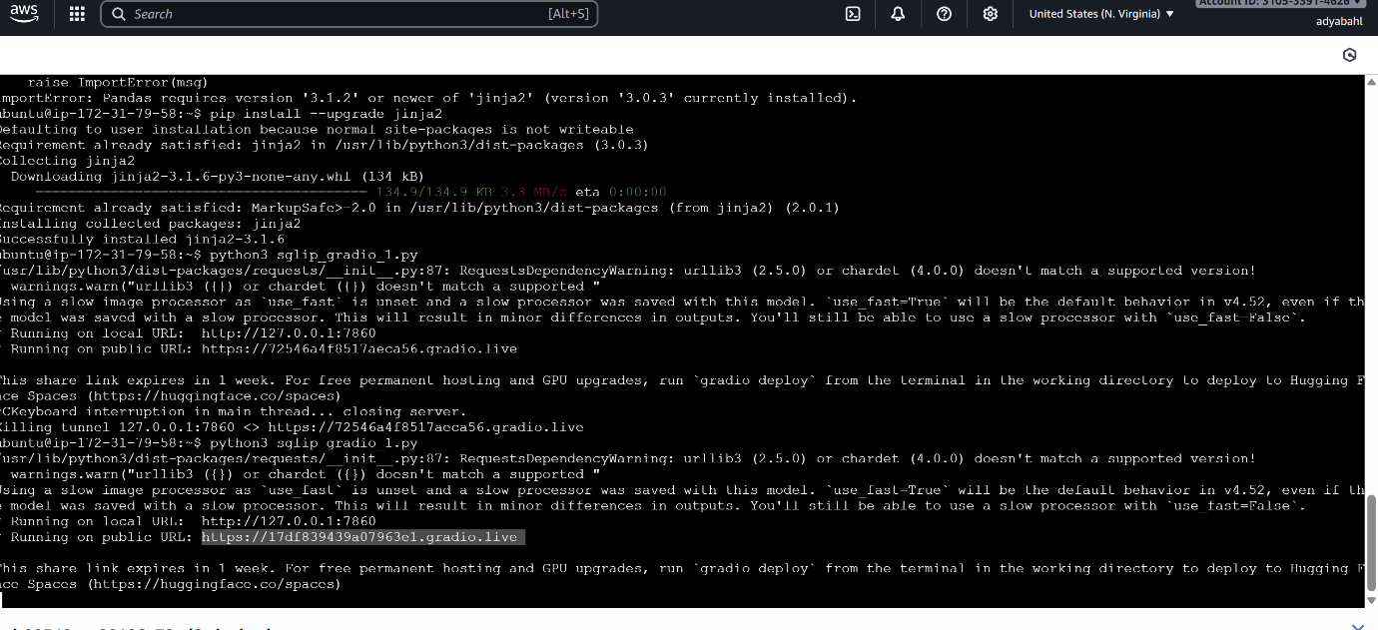

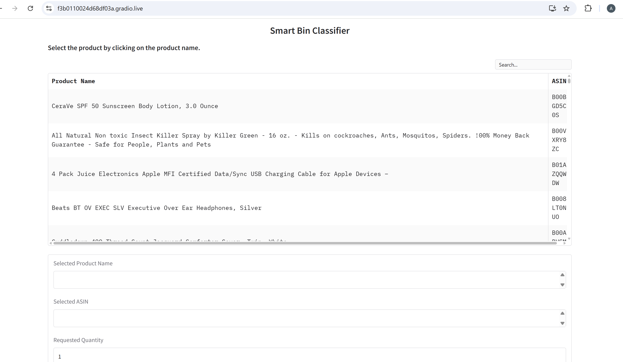

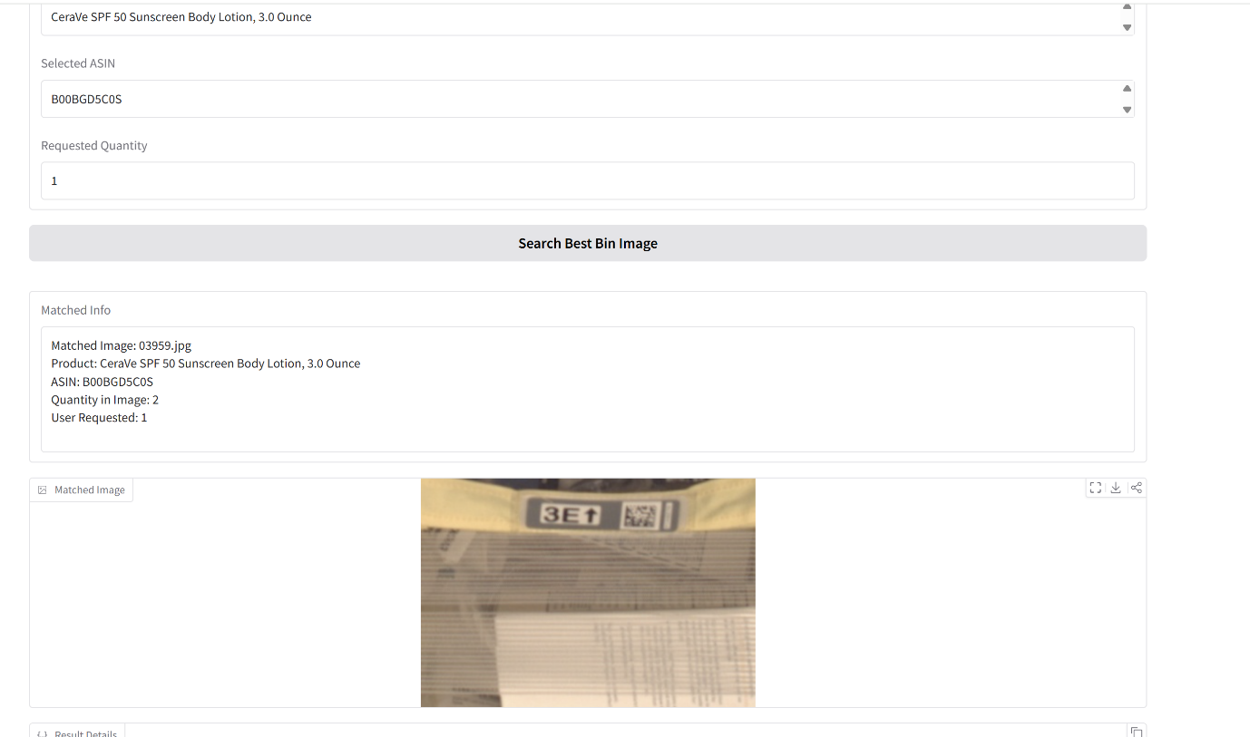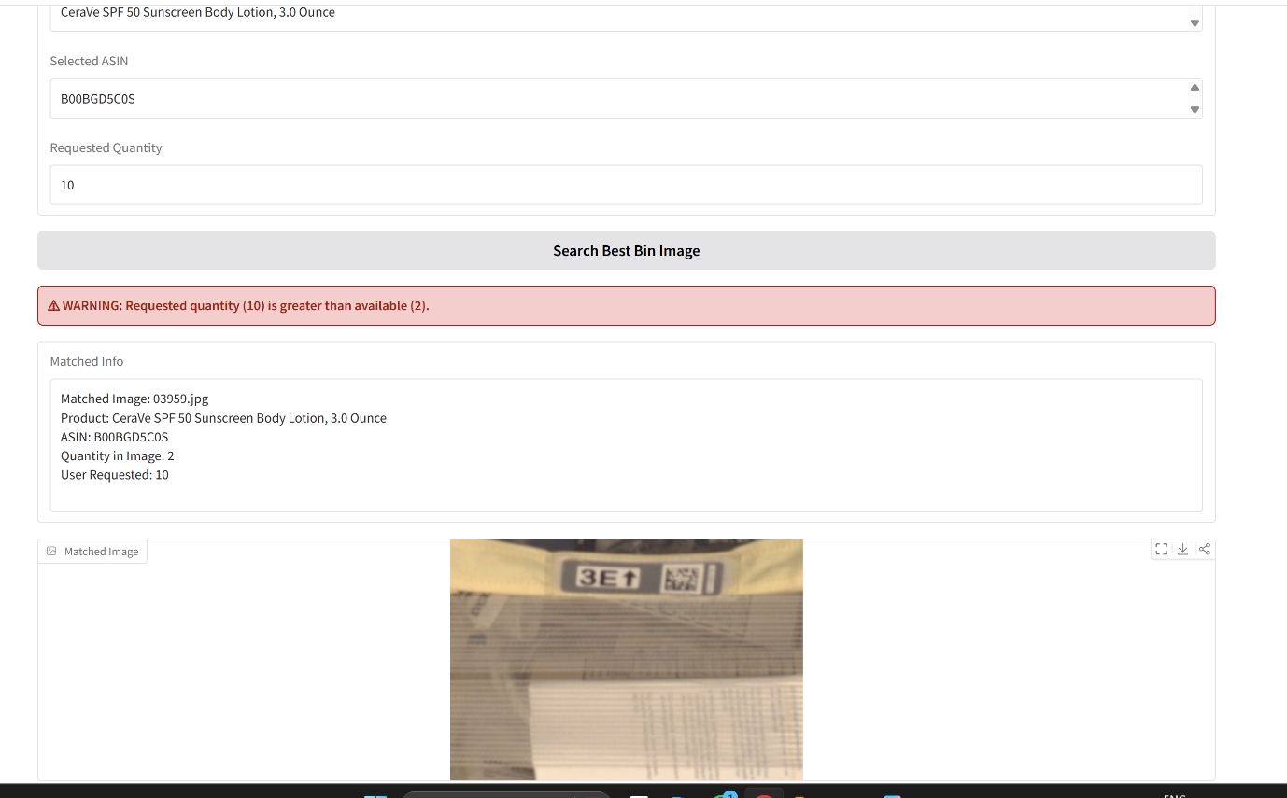

7. Final Summary
The Smart Bin Classifier evolved from limited classification-based attempts into a powerful SIGLIP-backed retrieval system that:
- Works for hundreds of ASINs
- Handles complex multi-item bins
- Matches both product name & quantity
- Delivers fast, intuitive results via UI
- Is ready for real-world scaling and MLOps integration
This final system is accurate, scalable, and significantly more practical than earlier Swin or CLIP approaches

